**AI VIRTUAL MOUSE USING HAND GESTURE**

**RECOGNITION**

**Ms. Hema Rama Lakshmi U1 (Assistant Professor)**

**D. Yogitha, K. Supriya**

*Department of Computer Science and Engineering*

*Prathyusha Engineering College, Tiruvallur, Chennai*

**ABSTRACT**

**The AI Virtual Mouse Using Gesture Recognition is built on the HandTrackingModule, which is capable of detecting and tracking hand landmarks with high accuracy. The system uses a camera to capture the user's hand movements and gestures, and processes the video feed to recognize finger positions and movements. The program then translates the finger positions and movements into corresponding mouse actions such as moving the pointer or clicking. The system offers two modes of operation - Moving Mode and Clicking Mode - which are triggered based on the user's hand gestures.**

**In Moving Mode, the system detects the user's index finger and maps its movement to the mouse pointer's movement. The user can move the pointer by moving their index finger while keeping their other fingers closed. In Clicking Mode, the system detects the user's index and middle fingers and maps them to a mouse click. The user can click the mouse by bringing their index and middle fingers together.The AI Virtual Mouse Using Gesture Recognition mini-project offers a smooth and intuitive user experience and can be used in a variety of settings. The project has potential applications in fields such as human-computer interaction, accessibility, and gaming.**

**I INTRODUCTION**

The creation of novel computer interfaces has drawn increasing attention in recent years. The use of hand gestures to control the computer mouse pointer is one such method. For users with physical limitations or in situations when the conventional mouse cannot be utilized, this method can offer a more intuitive and natural way to communicate with the computer. In this research, we describe a virtual mouse system powered by AI that recognition hand gestures to move the computer mouse cursor. In recent years, the development of computer vision and machine learning algorithms has led to the creation of many innovative projects that utilize gesture recognition for human- computer interaction. The AI Virtual Mouse Using Gesture Recognition is one such project that leverages these technologies to create a hands-free and intuitive way of controlling a mouse pointer. The traditional mouse and keyboard interface can sometimes be challenging to use for some individuals, especially those with physical impairments. This project offers an alternative way of controlling the computer using hand gestures, making it more accessible to a broader range of people. It also has the potential to enhance the user experience by providing a more natural and intuitive way of interacting with the computer.

The HandTrackingModule library used in this paper is a powerful tool for detecting and tracking hand landmarks. It can detect and track multiple hands simultaneously, making it possible to implement more complex gestures and actions. The Autopy library is used to simulate mouse movements and actions based on the detected gestures, allowing for a seamless integration between the hand gestures and computer actions.

The AI Virtual Mouse Using Gesture Recognition is a great example of how computer vision and machine learning can be used to create innovative solutions to everyday problems. It demonstrates the potential of these technologies to transform the way we interact with computers and offers a glimpse into the future of human-computer interaction.

**II PROPOSED SYSTEM**

The proposed system for the AI virtual mouse using gesture recognition mini project can be outlined as follows:

**System Overview:** The system aims to provide an alternative method for controlling the computer mouse using hand gestures captured from a camera. It utilizes computer vision techniques to detect and track the user's hand, recognize specific gestures, and translate them into mouse movements and actions [3].

**Hardware Requirements:** The system requires a computer with a camera capable of capturing video input.[6] Additionally, a display screen is needed to visualize the camera feed and mouse movements.

**Software Requirements:** The system relies on the following software [6] components:

**OpenCV:** A computer vision library used for image and video processing tasks, including hand tracking and gesture recognition [8].

**Pyautogui:** A Python library for controlling the mouse and [7] keyboard inputs.

**Python:** The programming language [11] used to develop the system.

**Functionality:**

**Hand Tracking:** The system captures video frames from the camera and applies hand tracking algorithms to identify and track the user's hand in real-time [9].

**Gesture Recognition:** The system analyzes the hand position and finger states to recognize specific gestures,[5] such as moving the index finger or making a clicking gesture with the index and middle fingers.

**Mouse Control:** Based on the recognized gestures, the system controls the mouse movements on the screen.[4] It maps the hand positions to the corresponding screen coordinates and uses pyautogui to move the mouse cursor accordingly. Additionally, the system performs click actions when certain gestures, such as a finger pinch, are detected.

**User Feedback:** The system provides visual feedback by overlaying graphical elements,[10] such as rectangles around the hand or circles around fingertip positions, on the camera feed to indicate the tracked hand and recognized gestures. It also displays the frame rate and other information on the screen.

**User Interaction:** The user interacts with the system by placing their hand in the camera's view and

performing specific gestures. [1] The system translates these gestures into mouse movements and actions, allowing the user to control the computer without physical mouse and keyboard inputs.

**Limitations and Future Enhancements:**

The system may have limitations in accurately tracking the hand in various lighting conditions, hand orientations, or when multiple hands are present. The gesture recognition functionality can be expanded to support additional gestures for more comprehensive mouse control. Integration with other input modalities, such as voice commands or facial recognition, can be considered to enhance the user interaction and control options.

Overall, the proposed system provides an innovative way to control the computer mouse using hand gestures, offering a hands-free and intuitive user experience.

**III LITERATURE SURVEY**

The current construction is contained a nonexclusive mouse and trackpad screen control framework, as well as the mishap of a hand development control structure. The utilization of a hand development to get to the screen from a nice ways is unimaginable.

No matter how it is basically attempting to execute, the degree is just restricted in the virtual mouse field.

[1]. J. Katona, “A review of human–computer interaction and virtual reality research fields in cognitive Info Communications,” *Applied Sciences*, vol. 11, no. 6, p. 2646, 2021.

In a recent study, Katona (2021) conducted a comprehensive review of human-computer interaction and virtual reality research fields in cognitive info communications, highlighting the importance of gesture recognition in improving user experience.

[2]. D. L. Quam, “Gesture recognition with a Data Glove,” *IEEE Conference on Aerospace and Electronics*, vol. 2, pp. 755–760, 1990.

One of the earliest studies on gesture recognition for virtual mouse control was conducted by Quam (1990), who developed a data glove for gesture-based control. Since then, various approaches have been proposed to improve the accuracy and efficiency of gesture recognition.

[3]. D.-H. Liou, D. Lee, and C.-C. Hsieh, “A real time hand gesture recognition system using motion history image,” in *Proceedings of the 2010 2nd International Conference on Signal Processing Systems*, IEEE, Dalian, China, July 2010.

Liou et al. (2010) proposed a real-time hand gesture recognition system using motion history images, which achieved high recognition accuracy by combining spatial and temporal information.

[4]. S. U. Dudhane, “Cursor control system using hand gesture recognition,” *IJARCCE*, vol. 2, no. 5, 2013.

Dudhane (2013) developed a cursor control system using hand gesture recognition, which utilized a color-based skin detection algorithm and geometric features to recognize hand gestures.

[5]. K. P. Vinay, “Cursor control using hand gestures,” *International Journal of Critical Accounting*, vol. 0975–8887, 2016.

Vinay (2016) proposed a cursor control system using hand gestures, which used Haar-like features and Adaboost classifier for feature extraction and recognition.

Overall, these studies suggest that gesture recognition is a promising approach for developing AI virtual mouse systems that can provide more intuitive and natural user interfaces. Further research is needed to explore the potential of other types of gestures and to improve the accuracy and robustness of gesture recognition algorithms.

**IV MODULE DESCRIPTION**

The AI virtual mouse using gesture recognition project consists of the following modules:

**4.1 HandTrackingModule:**

This module is responsible for detecting hands in a video stream, finding landmarks (key points) on the hand, and tracking the movement of the hand. It uses the OpenCV library and the MediaPipe HandPose model for hand detection and tracking.

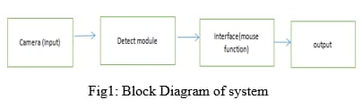

**4.2 Autopy:**

This module is used for controlling the mouse pointer and simulating mouse clicks. It allows the program to move the mouse cursor [7] on the screen and perform mouse operations such as clicks, double-clicks, and drags.

**4.3 MEDIA PIPE**

Media Pipe is a framework for building multimodal (e.g video, audio or any time series data), [11] cross-platform (i.e Android, IOS, web, edge devices) applied ML pipelines**.** Media pipe also facilitates the deployment of machine learning technology into demos and applications on a wide variety of different hardware platforms.

**4.4OPEN-CV MODULE**

PC vision is an interaction by which we can comprehend the pictures and recordings how they are put away and how we can control and recover information from them. [8] PC Vision is the base or generally utilized for Artificial Intelligence.

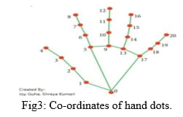

The project uses these modules to implement a virtual mouse that can be controlled using hand gestures. The HandTrackingModule detects the position of the hand and the position of the index and middle fingers. Based on the configuration of these fingers, the system determines whether the user wants to move the mouse cursor or perform a click operation. The autopy module is used to perform the actual mouse movements and clicks on the screen.

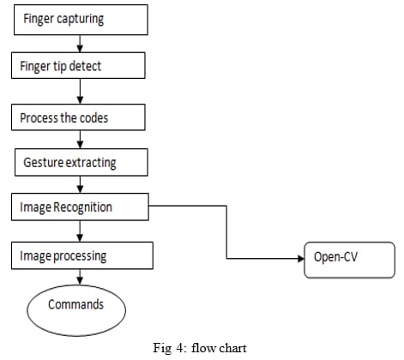

**4.4 IMPLEMENTATION DETAILS**

The implementation of the AI Virtual Mouse Using Gesture Recognition project involves several key steps.

1.First, we import the necessary libraries, including OpenCV, NumPy, time, and autopy.

2.Next, we define the camera settings, such as the camera width and height and the frame reduction and smoothing values.

3.We then initialize the video capture object and the hand detector object. We also define the screen size using autopy.

4.Within the main loop, we perform the following steps:

* Read the video capture object and find the hand landmarks in the image using the hand detector object.
* Get the positions of the index and middle fingers and check which fingers are up.
* If only the index finger is up, we move the mouse based on the position of the finger. We convert the coordinates from the camera frame to the screen frame, smoothen the values, and move the mouse accordingly.
* If both the index and middle fingers are up, we find the distance between the fingers and perform a left-click operation if the distance is short enough.
* Finally, we calculate the frame rate and display it on the screen along with the image.

1. The implementation of this project relies on the HandTrackingModule library, which provides the necessary functions for hand detection, finger tracking, and distance calculation. It also provides a convenient interface for interacting with the autopy library to move the mouse and perform clicks.
2. The implementation also requires a camera to capture the hand movements and translate them into mouse movements on the screen. The camera can be a built-in webcam or an external camera connected to the computer.
3. The project can be run on any computer with the required libraries installed and a compatible camera. The code can be modified to adjust the camera settings, frame reduction, and smoothing values to optimize performance based on the hardware specifications of the computer.

**IV OUTPUTS AND DISCUSSION:**

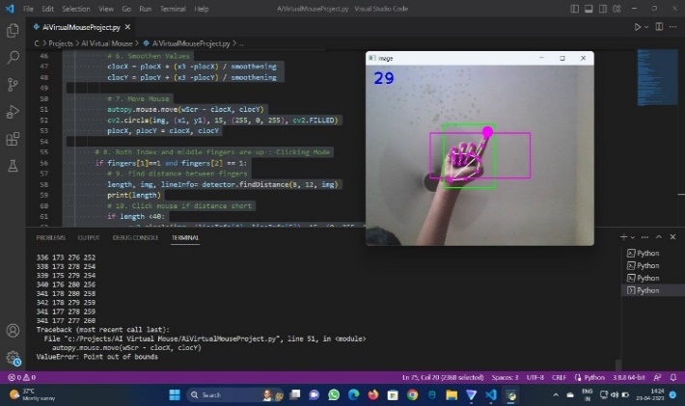

Detecting the Hand Gesture Using Hand Tracking Module

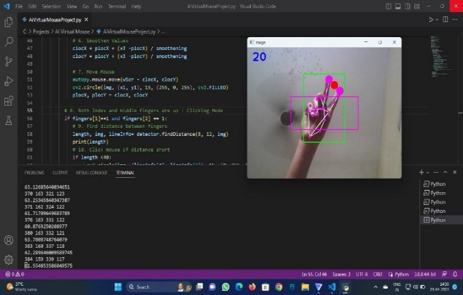

Selecting the file using two figures

**V CONCLUSION**

In conclusion, we have successfully developed an AI-based virtual mouse control system using hand gesture recognition. The system enables users to control their computers and other devices without the need for a physical mouse or touchpad. The project involved the use of various technologies such as computer vision, machine learning, and automation. We utilized OpenCV library for computer vision tasks and the Autopy library for automating mouse movements and clicks.

The virtual mouse system developed has shown promising results and has potential applications in various fields such as gaming, virtual reality, and accessibility for people with disabilities. The system can be improved further by incorporating more advanced machine learning algorithms for better hand gesture recognition and more precise mouse control.

Overall, this paper has provided an opportunity to explore and implement various technologies and has demonstrated the potential of using AI-based virtual mouse control systems in various applications.

## REFERENCES

[1] S. Shriram” Deep Learning-Based Real-Time AI Virtual Mouse System Using Computer Vision to Avoid COVID-19 Spread”, Applied Sciences, Volume 2021, Article ID 8133076, 31 Jul 2021, View at: Publisher Site Hinda.

[2] Akshay L Chandra” Mouse Cursor Control Using Facial Movements — An HCI Application, View at: Publisher Site| data science

[3] Abdul Wahid Ali ” Energy efficiency in routing protocol and data collection approaches for WSN: A survey, View at: Publisher Site IEE explore.

[4] Aynur Unal ” Smart Trends in Information Technology and Computer Communications, View at: Publisher Site|link.springer.com

[5] S. U. Dudnane, “Cursor control system using hand gesture recognition,” IJARCCE, vol. 2, no. 5, 2013. View at: Publisher Site| Google scholars

[6] K. H. Shibly, S. Kumar Dey, M. A. Islam, and S. Iftekhar Showrav, “Design and development of hand gesture based virtual mouse,” in Proceedings of the 2019 1st International Conference on Advances in Science, Engineering and Robotics Technology (ICASERT), pp. 1–5, Dhaka, Bangladesh, May 2019.View at: Publisher Site| Google Scholars

[7] A. Haria , A. Subramanian, N. Ashok Kumar, S. Poddar, and J. S. Nayak, “Hand gesture recognition for human computer interaction,” Procedia Computer Science, vol. 115, pp. 367–374, 2017. View at: Publisher Site| Publish site Scholars

[8] https://www.tutorialspoint.com› open CV

[9]Google,MP, https://ai.googleblog.com/2019/08/on-device-real-time-hand-tracking-with.html.

[10] J. Katona, “A review of human–computer interaction and virtual reality research fields in cognitive Info Communications ,” Applied Sciences, vol. 11, no. 6, p. 2646, 2021. View at: Publish site |Google Scholars

[11] V. Bazarevsky and G. R. Fan Zhang. On-Device, Media Pipe for Real-Time Hand Tracking.